# **Factories and Seeders**

Navigate to use dummy datas

## **Overview**

To start development you must have datas stored in database to use in your application. Some developer using [json placeholder](https://jsonplaceholder.typicode.com/posts) but in Laravel there is Factories and Seeders.

## **Laravel Factories**

The Laravel factory generated a defined object which having table column that connects to your database model.

### Creating Factory

In order to create factory in Laravel you need to put this command in your terminal “**php artisan make:factory NameofFactory”.** In my case I created TodoFactory and its generated on this path “**app/database/factories/TodoFactory.php**”

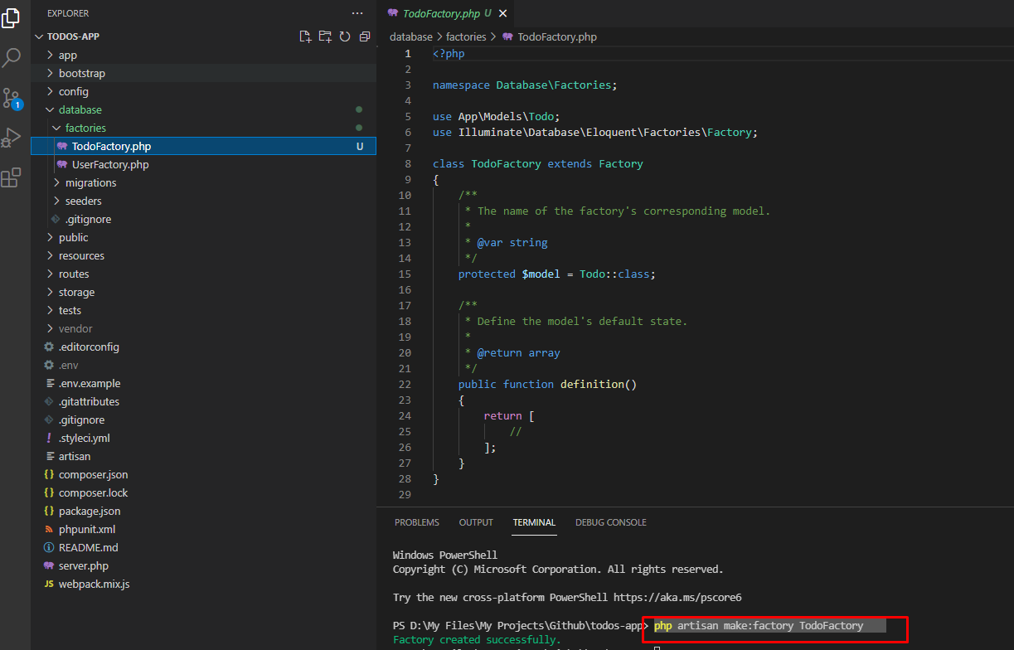

### Editing Factory

In Laravel version 8, the factory has already a model. If you already created a database model in a previous doc. Migrations and Model. Laravel adapted the setting of your model and used it to your factory so no need to add model.

<?php

namespace Database\Factories;

use App\Models\Todo; // <--- Model of your database

use Illuminate\Database\Eloquent\Factories\Factory;

class TodoFactory extends Factory

{

    /**

     * The name of the factory's corresponding model.

     *

     * @var string

     */

    protected $model = Todo::class; // <--- Model of your database

    /**

     * Define the model's default state.

     *

     * @return array

     */

    public function definition()

    {

        return [

            //

        ];

    }

}

Go to the definition and add your fake table column there to connect it in your database todos table. **Notes: fake models/table columns must same in your database table column/models.**

public function definition()

    {

        return [

            'name' => $this->faker->sentence(3),

            'description' => $this->faker->paragraph(4),

            'completed' => false,

        ];

    }

My database todo model/table column. The id is auto_increment and create_at and updated_at will be auto generated so no need to add in factory see above image.

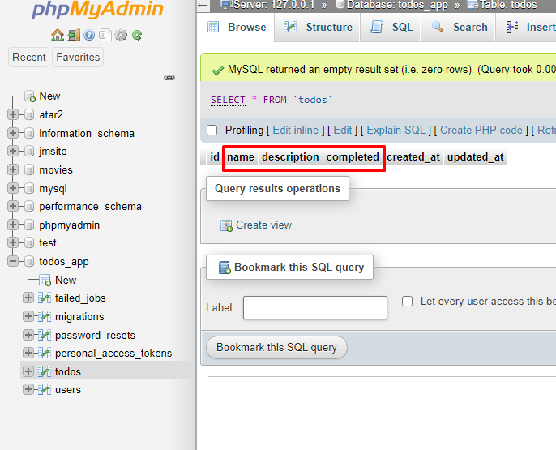

## **Laravel Seeder**

Laravel seeders is a dummy data generator for your given table and it’s connected to your factory in my case its TodoFactory.php at “**app/database/factories**”.

### Creating Seeder

To create seeder you can run this command “ **php artisan make:seed NameofSeeder** ”. After running this command there’s a generated file at “**app/database/seeders/NameofSeeder**”.

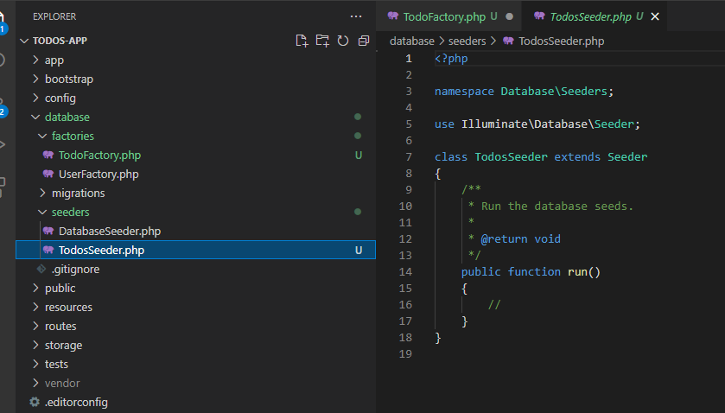

### Steps to modify Seeder

1. You need to add this line of code in run function of your seeder in my case its TodosSeeder.

public function run(){

\App\Models\Todo::factory(10)->create();

}

**Explanation in code above**

\App\Models\Todo  //<-- call the Todo Class using namespace

::factory(10) //<-- call a function inside Todo Class Model It has 10 arguement means loop 10x times the factory

->create(); //<-- call the create function in factory rhan you created

1. Now go to the **DatabaseSeeder.php** at this path “**database/seeders/ DatabaseSeeder.php**”. Then add this line of code to call TodosSeeder and run the factory seeding

public function run(){

$this->call(TodosSeeder::class); //this will can the run function in TodosSeeder

}

1. Then run this command to seeds data with your factory to your database. “**php artisan db:seed**”
2. Go to your database and see if seeded data is there.

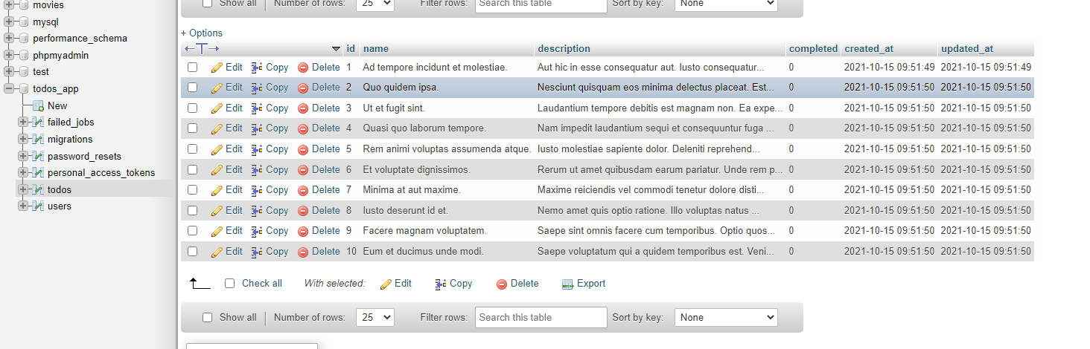

**It works!.. 😉**